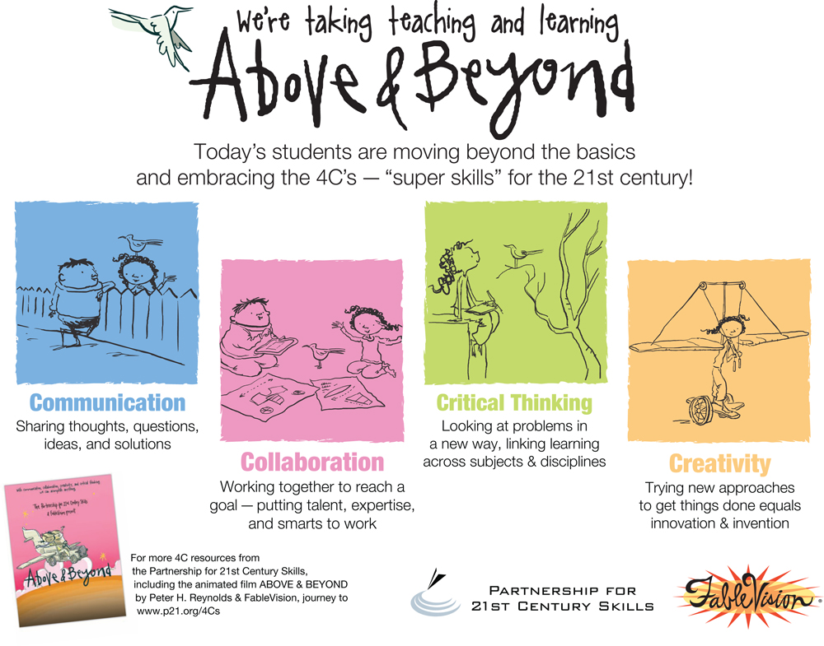What does this look like in our classroom?
​Communication
To communicate effectively students will share thoughts, questions, ideas, and solutions. We will also practice listening effectively to others.
​Collaboration
Students will be working together to reach a common goal. Students will put together their own skills, talents, and expertise to contribute to their group's goals.
Students will be working together to reach a common goal sharing responsibility of work and valuing contributions of others
​Critical Thinking
We are using our critical thinking skills when speaking, reading, and writing! Students are encouraged to always justify their opinions. Students will tell their thinking followed by 'because' and then their justification. Justifying their answers should show their thinking by using text based, schema-based, and/or real world based examples and evidence.
When students are working with small groups (especially book clubs), students should keep conversations going by asking open-ended text-based questions (in your head questions).
Creativity
Student will invent and trying new approaches to get things done. It is important to learn from failed attempts.
​​​

